Media Kit – Masada: Thou Shalt Not Kill by Shimon Avish

Contents
Headshots 1
Book Covers 2
Biographies 3
Book Descriptions 4
Series Description 5
Blurbs/Testimonials 6

Headshots

Book Covers
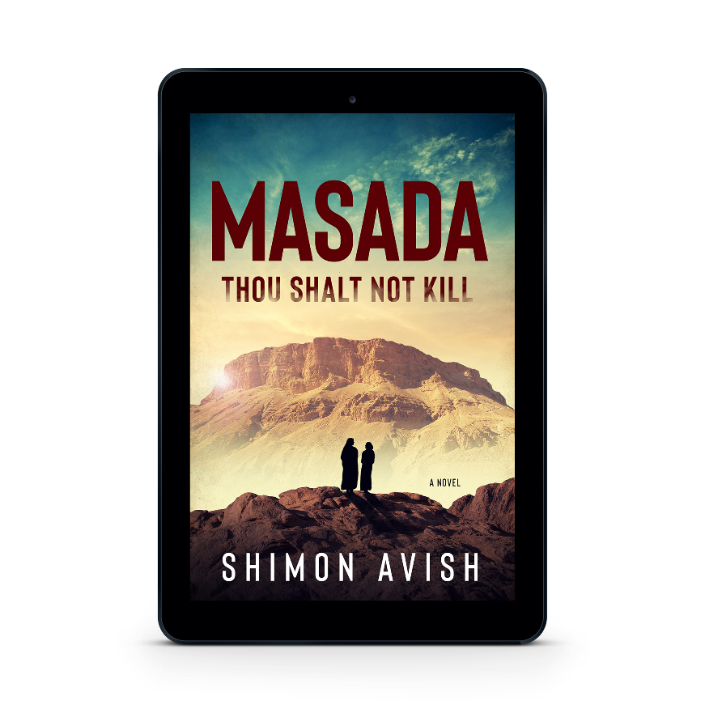
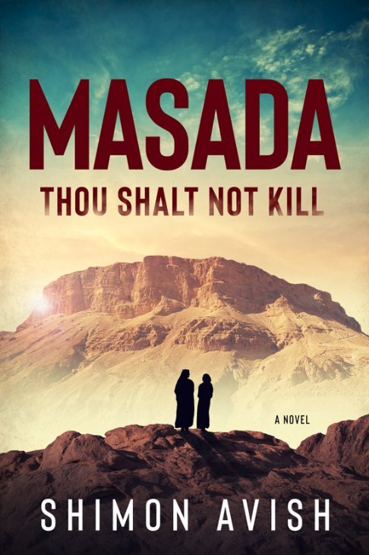
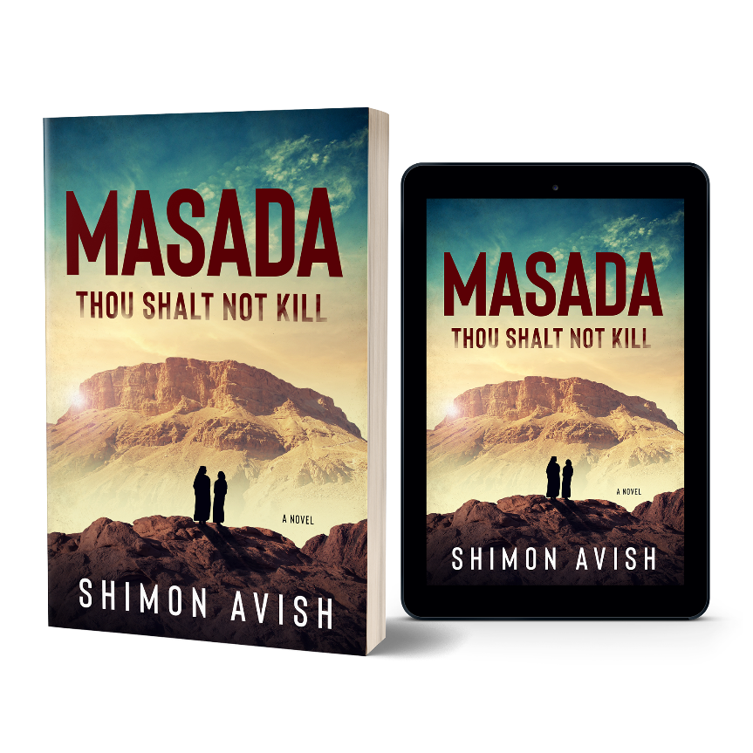
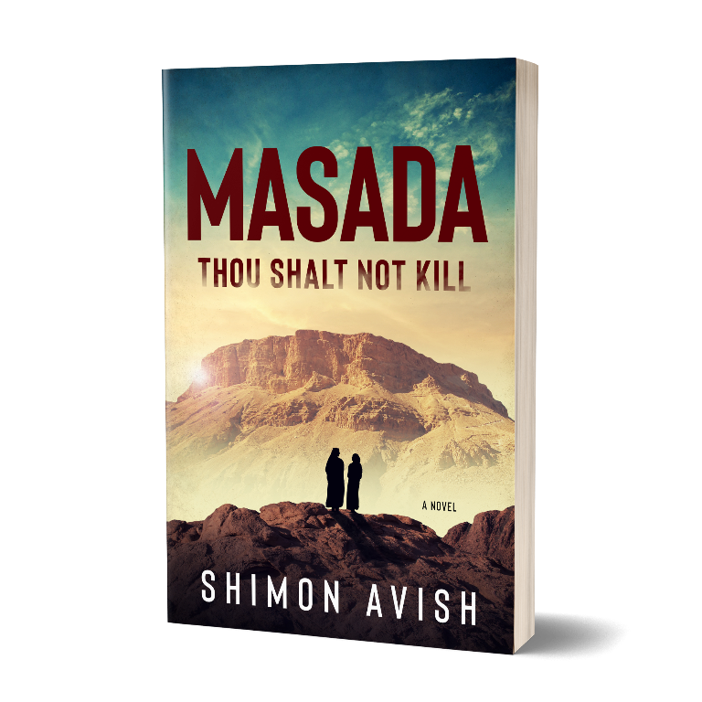

Biographies

Short Bio
SHIMON AVISH writes about significant events in ancient Jewish history. His work draws on his adventures in soldiering, farming, product design, cabinet making, political science, international business consulting and living in the U.S., Canada, and Israel.

Long Bio
SHIMON AVISH writes about significant events in ancient Jewish history. His work draws on his adventures in soldiering, farming, product design, cabinet making, political science, international business consulting and living in the U.S., Canada, and Israel. He completed his doctoral degree in political science at Columbia University in the City of New York and was a Fulbright-Hays Fellow.

Book Descriptions

Short
Daniel, the son of a Temple priest in ancient Jerusalem, is abducted by the Sicarii or dagger men when he witnesses their assassination of the High Priest. They take him away to Masada, a desert fortress, where he is forced to adapt to the Sicarii way of life to survive. That is until the Roman Tenth Legion arrives to eliminate the Sicarii when his choices become even starker.

Long
When 18-year-old Daniel is abducted by Sicarii assassins and taken to their walled fortress of Masada, he's forced to let go of the Jewish Law he's learned from his parents and adopt his kidnappers' code of violence and thievery simply to stay alive.
Wracked with guilt but determined to survive, Daniel becomes part of the Sicarii culture, even marrying one of their soldier's sisters. Between violent raids against neighboring settlements to prevent starvation and other challenges to his beliefs, Daniel is faced with choice after choice that tests his character, strength, and resolve and pushes him to discover the kind of man he wants to be.
Set against the backdrop of the last confrontation between the Jews and Romans during the Second Temple period, author Shimon Avish masterfully weaves together history and his real-life experiences in the army and as a kibbutznik, bringing to life a painful chapter in Jewish history through the eyes of young Daniel.

Series Description

Significant Events in Ancient Jewish History
Jewish history is replete with incredible stories, but many of us don't know them. Short of spending time reading the bible, how could we? Therefore, I am developing a series of historical fiction novels on significant events in ancient Jewish history, including the following books to begin with:
- Rome and the Jews: Prelude to War (First Jewish–Roman War – 6 BCE–70 CE)
- Jerusalem: Siege and Destruction (First Jewish–Roman War – 66-70 C.E.)
- Masada: Thou Shalt Not Kill (First Jewish–Roman War – 66-70 C.E.)
- The Second Jewish Rebellion Against Rome (Kitos War – 115–117 CE)
- The Third Jewish Rebellion Against Rome (Bar Kokhba Revolt – 132–135 CE)
These books tell stories of specific events, but they also have a point of view regarding the morality of the issues found in the books from a universal perspective. Masada: Thou Shalt Not Kill, for example, looks at the use of violence and whether it is ever acceptable to resort to violence to solve intractable problems. It also explores how perpetrating violence affects the wrongdoer and how being powerful enough to end a life changes people in ways they cannot anticipate.

Blurbs/Testimonials

"A striking narrative interwoven with biblical history and appealing characters - if you loved "The Dovekeepers" by Alice Hoffman, then don't miss this one!" –Historical Fiction Company

"Shimon Avish's debut novel is a captivating retelling of the Masada story…combining vivid characters, rich language, and a relentless plot." –Benjamin Buchholz, author of Sirens of Manhattan

"… the book will appeal to readers of historical novels, especially to those fascinated by the legend of the nearly unassailable Masada fortress." –Ellis Shuman, author of The Burgas Affair

"This work is very well researched and beautifully written. This is a MUST read for anyone interested in the mystery of Masada." –Leoma Gilley, author of The Still Small Voice of Love

